BONDING
Bonding is the chemical combination of atoms or elements to form compounds. The force of attraction holding atoms or elements together in a molecule/crystal is referred to as a chemical bond. Chemical bonding /combination occurs mainly in four forms as:
- Ionic/electrovalent bonding-this involves transfer of electrons from a metal atom to a non metal atom. It occurs between metals and non metals

- Covalent bonding-this involves sharing of electrons between two or more non metal atoms/elements. The atoms/elements involved contribute to the bonding electrons.
- Dative/co-ordinate bonding-this involves sharing of the bonding electrons which are donated by one molecule or atom involved.
- Metallic bonding-this occurs between atoms of metal elements.
Electrovalent/ ionic bonding
This involves transfer of electrons from a metal to a non metal. The number of electrons lost by the metal atom or gained by non metal atom is equivalent to its valency. The loss of electrons from a metal atom leads to formation of a positively charged ion (cation) and the gain of electrons by a non metal atom leads to the formation of a negatively charged ion (anion). The positively charged ion and the negatively charged ion are attracted to each other and the force of attraction holding them together is known as electrovalent/ionic bond. The compounds formed are referred to as ionic/
electrovalent compounds. Metal atoms lose electrons so as to gain stable electronic configuration of noble gases and non metal atoms also gain electrons to become stable.
Formation of some ionic compounds
Sodium chloride
When sodium burns in chlorine to form sodium chloride, the sodium atom loses an electron and forms a positively charged sodium ion(Na+) while the chlorine atom gains the electron and forms a negatively charged chloride ion ( ).
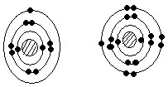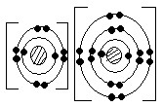
The positively charged sodium ion and negatively charged chlorine ion are attracted to each other by a strong force called ionic bond.

Magnesium oxide
Magnesium atom loses two electrons to the oxygen atom and forms a positively charged magnesium ion ( ) while the oxygen atom forms a negatively charged oxide ion ( ). These two oppositely charged ions are then attracted to each other.
Illustration
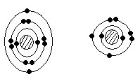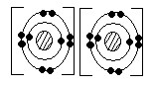

Calcium chloride
During the formation of calcium chloride, calcium atom loses two electrons which are gained by two chlorine atoms. This leads to the formation of and two which are then attracted to each other.
Illustration

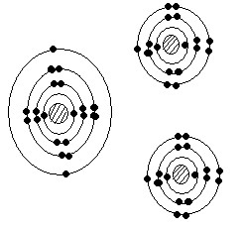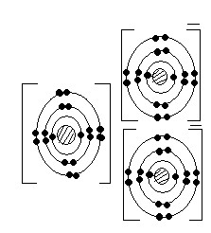

Covalent bonding
This type of bonding occurs between non metal elements/ atoms to form compounds. Covalent bonding involves mutual sharing of electrons between elements in which each of the atoms involved gives equal number of electrons to be shared. On sharing the electrons, the atoms attain stable electronic structure of noble gases. The compound formed are called covalent compounds. Covalent bonds may by classified as single, double, triple or quadruple depending on the number of electrons shared.
a) Single covalent bond: this is formed when one pair of electron is shared. Each of the atoms involved contribute an electron for the bond formation.

Example
i) Hydrogen molecule (H2)
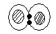

Water molecule (H2O)
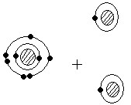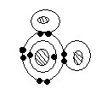
- Ammonia (NH3)

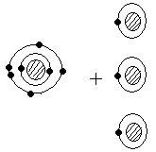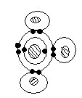
- Methane (CH4)

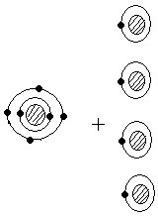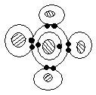
N.B. The pair of electron on the outer most energy level that does not take part in bonding is the lone pair or non bonded pair.

b) Double covalent bond

This is formed when two pairs of electrons are shared between two bonded atoms.
Example
i) Oxygen (O2)
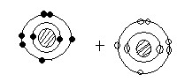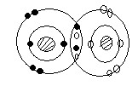

Ideal Chemistry – A complete approach for “O” level Page 118

ii) Carbon dioxide (CO2)
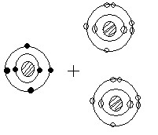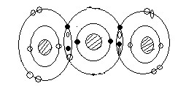

c) Triple covalent bond
This involves sharing of three pairs of electrons between atoms.
Example
- Nitrogen molecule (N2)
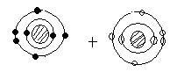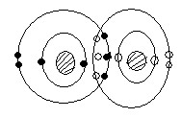

- Hydrogen cyanide (HCN)
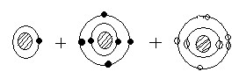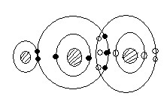

d) Quadruple covalent bond
This is formed by sharing four pairs of electrons. It occurs between carbon atoms.
Illustration
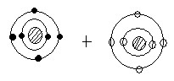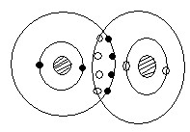

Dative/ co-ordinate bond
This involves sharing of electrons but the shared pair of electrons is donated by one atom/ molecule.
Here, one molecule/ atom donates the pair of electrons to be shared with an ion or another atom. Normally it is atoms/ molecules with lone pair of electrons that form this bond-by donating the lone pair of electrons to be shared with another atom/ion. The bond may be represented by an arrow originating from thedonor atom (atom that donates electrons to be shared) to the atom accepting the electrons.
Example
- Formation of ammonium ion ( )

During the formation of ammonium ion, ammonia reacts with an acid. The nitrogen in ammonia has a lone pair of electron which it donates to be shared with the hydrogen ion (proton) from the acid.
NH3 +
Illustration
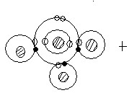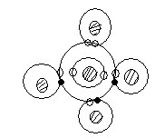

- Formation of phosphorus (V) trichloride oxide.
This is formed between phosphorus (III) chloride which donates the lone pair of electron to be shared and oxygen atom.
Illustration using outer most shell
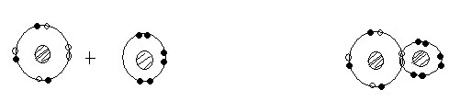

Metallic bonding
This is the type of bonding in metals due to the attraction between metal ions and the valency electrons within the structure of the metal (metal lattice). In the structure of a metal, the loosely held valency electrons (electrons in the outer mos energy level) are released in to a general pool and the atoms become positively charged. These electrons move freely around the ions formed and are termed as mobile/delocalized electrons.
The ions formed and the electrons attract each other forming metallic bond.
The strength of metallic bond increases with increase in the number of electrons released in to the electron cloud. Thus the bond is very strong in metals like iron and aluminum that release up to three electrons each to the electron pool and weak in metals like sodium and potassium that only release one electron each to the electron pool.
Illustration
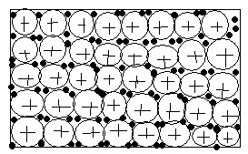

STRUCTURE OF COMPOUNDS/SUBSTANCES
Different types of binds give rise Structure to different types of structures. This is illustrated in the table

below. Bonding
Ionic/ electrovalent Giant ionic structure
Covalent Simple molecular structure
Giant molecular structure
Metallic Giant metallic
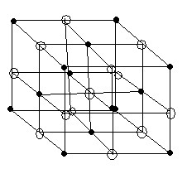
Each sodium ion is surrounded by six chloride ions and each chloride ion is also surrounded by six sodium ions. The coordination number is there fore 6:6.

Properties of ionic compounds
- They are solids with a regular shape. This is because of the strong electrostatic forces of attraction keeping the ions closely packed.
- They have high melting points. This is due to the strong electrostatic force af attraction between oppositely charged ions.
- They do not conduct electricity in solid states but do conduct in their molten states or solution form. This is because in solid states, the ions are localized and the electrons are not mobile but in molten form, the ions and electrons are free to move (electrons become delocalized) and thus conduct electricity.
- They have high density as the ions are closely packed.
- Ionic compounds are soluble in water and other polar solvents but they a re insoluble in organic solvents like benzene. Ionic compounds dissolve in polar solvents like water as the ions are attracted by the polar molecule.

A polar compound is a covalent compound in which charge separation exist between atoms. This is due to the differences in electro negativity between the atoms.
Electro negativity is the tendency of an atom to attract bonding electron towards itself. Electro positivity is the tendency of an atom to push away bonding electrons from itself.
For example, in a water molecule oxygen is more electro negative and attracts the bonding electrons towards itself giving it a partial negative charge. Hydrogen attains a partial positive charge. Structure of a water molecule

NB Most metals are malleable and ductile. This is because, since the bonding agent in a metal is a moving electron cloud, the ions of the metal; usually slide relative to one another under stress (without shattering the lattice and produce a new position of stability).

Simple molecular structures
The structure consists of simple independent molecules joined together by weak intermolecular forces of attraction. E.g. Vander Waal‘s force of attraction. The atoms in the molecule are held together by strong covalent bond. Compounds with this structure exist as gases, liquids or solids with low melting points. Examples include iodine, carbon dioxide , ammonia and water
Structure of iodine
Illustration of weak hydrogen bond in water
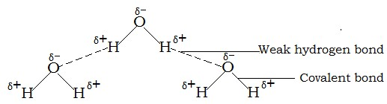

Properties of simple molecular structures
- They have low melting and boiling points because the molecules are held by weak intermolecular forces of attraction.
- They are non conductors of electricity because they do not have mobile electrons/ ions.
- Most of them are gases and liquids. Very few are solids.
- They have low densities as the molecules are not closely packed.
- They dissolve in organic solvents.

Giant atomic/molecular structure
Compounds with such structures consist of molecules /atoms linked together by strong covalent bonds resulting into a giant three dimensional or three dimensional structures like in graphite and diamond respectively (see details under Carbon and its compounds)

Properties of giant molecular structures
- They have high melting and boiling pints because of great energy needed to break the bonds.
- They do not conduct electricity except graphite which has delocalized electrons.
- They are insoluble in water.

Giant metallic structure
Giant metallic structure consists of very many metal ions surrounded by a sea /cloud of electrons. These electrons are released by metal atoms.

Properties of giant metallic structures
- They are solids with high melting and boiling points except mercury which is a liquid. 2. They conduct electricity in

- They do not conduct electricity except graphite which has delocalized electrons.
- They are insoluble in water. Giant metallic structure
Giant metallic structure consists of very many metal ions surrounded by a sea /cloud of electrons. These electrons are released by metal atoms.

Properties of giant metallic structures
- They are solids with high melting and boiling points except mercury which is a liquid.
- They conduct electricity in both liquid and solid states due to the presence of mobile electrons.

O-LEVEL CHEMISTRY

Ideal Chemistry – A complete approach for “O” level Page 123

Sample questions on bonding and structure
Bonding and structure
- Describe briefly what is meant by the following types of bonding: electrovalent, covalent, coordinate and metallic. Use examples to illustrate how the above bonds are formed between any two named atoms or molecules.
- Explain what is meant by metallic bond. Explain why a typical metal is (a) a good conductor of electricity (b) a good conductor of heat (c) in some conditions at leas malleable and ductile.
- The compounds named below are all covalent compounds. With the aid of the table of electron structures, give a diagram for a molecule of each of these compounds showing the outer most electron shells only: (i) tetra chloromethane CCl₄, phosphorus(III) chloride PCl₃ (iii) silane SiH₄ (iv) tri chloromethane CHCl₃ (v) phosphine PH₃ and (vi) dichloromethane CH₂Cl₂
- Explain briefly why ammonia and oxygen molecules participate readily in coordinate bonding. Give an example for the formation of an ion by ammonia by this means. Show by means of electronic diagram the formation of a coordinate linkage between phosphorus tri chloride and oxygen.
- By means of electronic diagrams, show the structure of (a) calcium atom (b) chlorine atom (c) calcium chloride. State the differences between electrovalent and covalent compounds.
- Describe how structures of the following compounds account for their property in term of electrical conduction (a) copper (b) graphite (c) diamond
- With the aid of well labeled drawings explain the structure of the following: Graphite, diamond, sodium chloride and chlorine molecule.

O-LEVEL CHEMISTRY
Ideal Chemistry – A complete approach for “O” level Page 124

CARBON AND ITS COMPOUNDS
Carbon is an element in period II and group IV in the periodic table. It has atomic number of six.

Occurrence of carbon
Carbon occurs in both free states and combined states. In combined states, it occurs as coal, mineral oils, carbonates (e.g. lime stone, marble and sea shells) and all living things (animals and plants). As an element it occurs in both natural (as diamond and graphite) and synthetic forms (as coke, charcoal and carbon fiber).

Allotropes of carbon
Allotropy is the existence of an element in two or more forms in the same physical state.
Allotropes are various forms in which elements exist without change in physical state.
Different allotropes of the same element always have different crystalline structures and physical properties but the same chemical properties.
Allotropes of carbon are: diamond and graphite. Another form of carbon is amorphous carbon.

Diamond
In diamond, the structure consists of infinite number of carbon atoms. Each of the carbon atoms is joined to four other

